Producing Gif animation pictures from Gif Movie Gear Ver 3

- Run Gif Movie Gear (GMG),,<Start from scratch>.
- Select Insert Frames from the File menu or click the toolbar button.
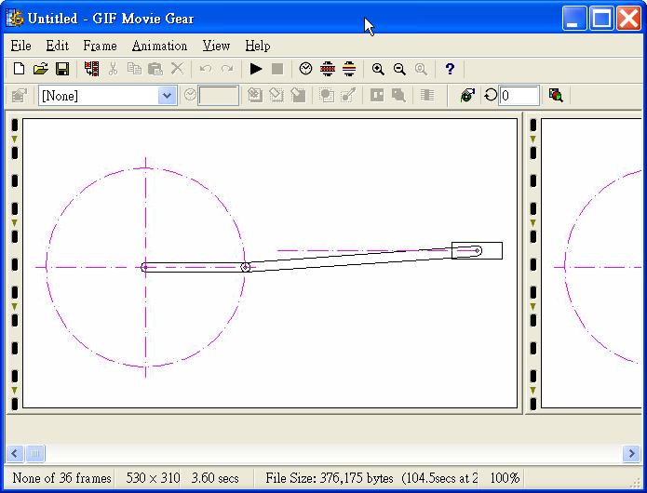
- Ordering frames: GMG imports GIF files according to how they are named. Reorder the frames if necessary.
- Previewing the Animation. Click on the Show Animation Preview toolbar buttonor use the keyboard shortcut: Ctrl+P.
- Save files as *.gif, and play it in Power point or AcdSee.
